TITLE; NO BLANK LINE BETWEEN THE TITLE AND THE PAPER TOP MARGIN CAPITAL LETTERS; PAGE-CENTERED; MAX. 2 LINES/70 TOTAL CHARACTERS

Forename Surname, Yıldız Technical University, name@domain.com
Forename Surname, Middle East Technical University, name@domain.com

PREPARATION AND SUBMITTAL
The Book of Abstracts, which will be given to participants at registration, will be reproduced directly from this file. Abstracts must be produced to fit 8.5 by 11-inch paper, The text, together with tables, equations and illustrations, must fill no more than one page, in 2-column layout (as in this accompanying example). Abstracts must be one page in length.

SUBHEADING
Authors are required to supply abstracts as PDF format files. Submissions can only be received via the online abstract submission system.

SUBHEADING
The official language of the conference: English. Paper Format: 8.5 by 11 inches, portrait. Margins: All the margins should be 1 inch from Top and Bottom, 0,7 inch from Left and Right. Columns: main text in two columns, justified; equal column width. Spacing: before and after: 0 pt: line spacing: single. Font: for the title: size 12 Microsoft Sans Serif, capital letters, bold; for the names of the authors: size 9 Microsoft Sans Serif, regular; for the text: size 9 Microsoft Sans Serif, regular. Page numbering: no page numbers. Title: leave no blank line between the title and the paper top margin; the title must be in capital letters, page-centered; maximum of two (2) lines and/or 70 total characters for the title. Name(s) of authors(s): leave 1 blank line after the title; the name of the authors and their affiliations must be presented as succinctly as possible, including the e-mail address of each author; leave one blank line before the main text. The name of the presented author should be underlined. Main text: in two columns, one page only, including figures and tables; paragraphs separated by one line. Footnotes: do not use footnotes. Figures and tables: include the figures and tables precisely in the place you want them.

SUBHEADING
Mathematics: equations should be typed into the body of the text, or incorporated as an equation editor or graphic object; equations should be numbered. Bibliographic references: in the text, indicate the last name of the author (no initials, please) followed by the year of publication in brackets; if there are several references of the same author in the same year, use a suffix a, b, .. after the year; make a list of references at the end of the text sorted by alphabetic order of the last name of the first author, followed by the names of the co-authors (if any), editor, place and year of publication (or complete reference of the journal where the article or paper was published). File format for submission: use PDF format; identify the files as “LastnameFirstname.pdf”, where the name is the presenting author; e.g. EdgeBilly.pdf.

If you have any queries on the preparation of your abstract, please contact Patrick Lynett at plynett@usc.edu

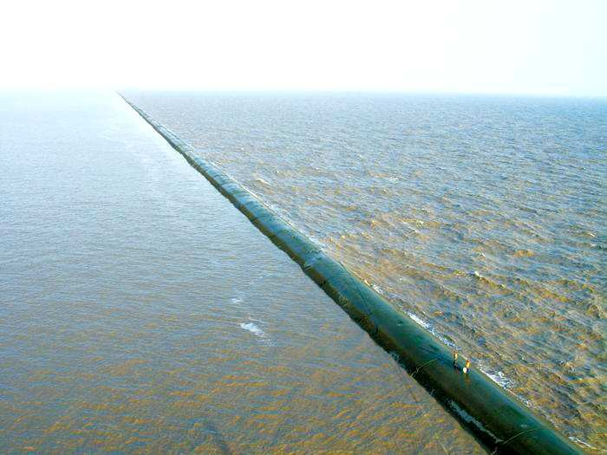
Figure 1 – Part of the Dyke in Yangtze River Estuary, Shanghai

ATTENTION
Please note that this example of the one-page abstract is a style sheet, which makes the work much easier. Please do not try to include more text on the single 8.5 by 11 inch page than the space provided by this instruction. If your one-page abstract does not comply with this instruction, it will be rejected.

REFERENCES
Surname no initials please (year of publication in brackets 2007):
Author, co-author (2006): Title, Coastal Engineering, ELSEVIER, vol. 10, pp. 32-39.

